Festivities RESTful API
Instructions
- Descompress Festivities.zip
- Modify application.properties that is inside Festivities-0.0.1-SNAPSHOT.jar with the right information about the PostgresDB’s configuration.
# URL DATABASE
spring.datasource.url = jdbc:postgresql://localhost/festivity

# Username and password
spring.datasource.username = postgres
spring.datasource.password = postgres2016
- Open terminal
- Go to the root of the Project (Festivities)
- Type:
java -jar target/Festivities-0.0.1-SNAPSHOT.jar

Load initial data
- Open a browser and go on
RequestMethod.GET
http://localhost:8080/festivityapi/festivity/load
This will take festivities.xml and execute ETL for creating the initial data

Queries
Find all festivities
RequestMethod.GET
http://localhost:8080/festivityapi/festivity/

Find by Name
RequestMethod.GET
http://localhost:8080/festivityapi/festivity/name?name=[name]

Find by Start Date
RequestMethod.GET
Date Format yyyy-MM-dd'T'HH:mm:ss.SSS'Z' (e.g. 2016-07-30T19:16:01.001Z)
http://localhost:8080/festivityapi//festivity/start_date?startDate=[startDate]

Find by Data Range
RequestMethod.GET
Date Format yyyy-MM-dd'T'HH:mm:ss.SSS'Z' (e.g. 2016-07-30T19:16:01.001Z)
http://localhost:8080/festivityapi//festivity/date_range?startDate=[ startDate] &endDate=[ endDate]

Find by Place
RequestMethod.GET
http://localhost:8080/festivityapi//festivity/name_place?namePlace=[namePlace]
New Festivity
RequestMethod.POST
Date Format yyyy-MM-dd'T'HH:mm:ss.SSS'Z' (e.g. 2016-07-30T19:16:01.001Z)
@RequestBody
JSON File
{
"name": "Jared's event 85",
"start": "2016-07-30T11:08:44.044Z",
"end": "2017-04-27T11:08:44.044Z",
"place": "Powell's joint"
}
http://localhost:8080/festivityapi//festivity/new
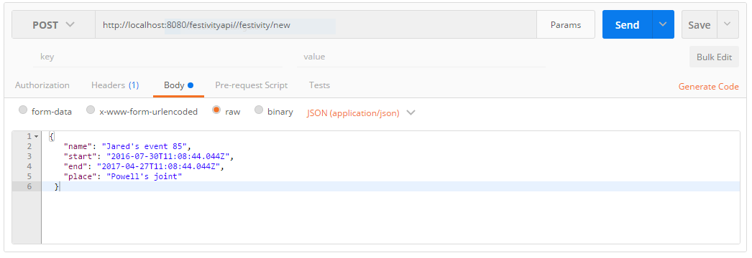

Update Festivity
RequestMethod.POST
Date Format yyyy-MM-dd'T'HH:mm:ss.SSS'Z' (e.g. 2016-07-30T19:16:01.001Z)
@RequestBody
JSON File
{
"name": "Jared's event 90",
"start": "2016-07-30T11:08:44.044Z",
"end": "2017-04-27T11:08:44.044Z"
}
http://localhost:8080/festivityapi//festivity/update?id=[id]
